Region Management Functional Requirements

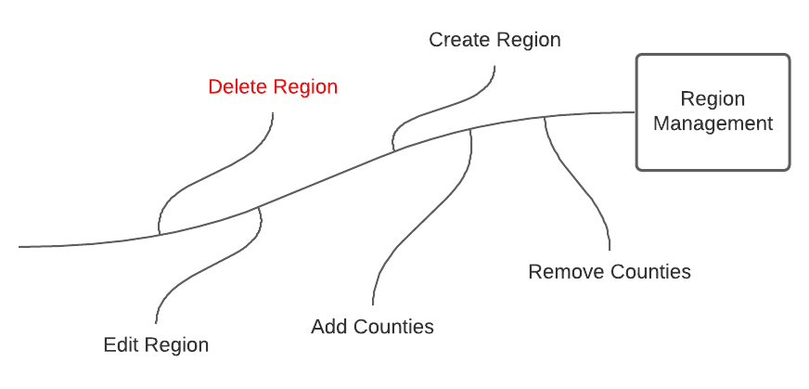

# Description

The Region Management system will allow users to create, define, and describe custom regions by adding counties that are geographically close together.

# Function Requirements

1. The system shall allow the Admin and Cartographers to add new regions to the collection of saved regions.
   1. A region’s creator must assign that region a name that differs from all other named regions in the collection.
   2. A region’s creator must populate that region with counties drawn from a list of counties that are named in one of the uploaded CHR datasets.
      1. Each region must contain at least two counties.
   3. A region’s creator may associate that region with a description.
2. The system will allow Cartographers and Admins to edit regions by removing or adding counties, altering the description, or renaming the region’s title.
3. The system will allow Cartographers and Admins to retrieve the names of all predefined regions created by all users.
4. The system will allow region creators to add a short descript about the defined regional area.
5. The system will track when the region was created, last updated, and who created it.
6. The system shall allow the deletion of regions with two conditions:
   1. If prompts the user with a warning message if the region is being used by a chart.
   2. It disables all the charts that were using the region after the region is deleted.

# County and Year Association for Counties Defined in a Region

Potentially, each year county names, FIPS codes, and data points can change. This creates a problem when defining a *Region of Counties* to use for a chart. If a county is nonexistent from a year that a data point is being used, this can create charting errors.

To avoid this potential error, while still allowing any CSV year to be associated with any county year, if a county is not in a specific year, the system will handle it as having no data. This will eliminate the use of tracking what year had specific counties across the United States.

In the case that a county was renamed or merged into another county, the region creator would need to add the old and new county. This would offset the chance of having no data while choosing a specific CSV year.